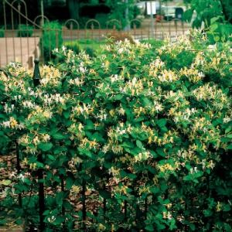
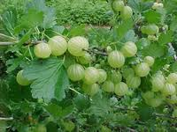
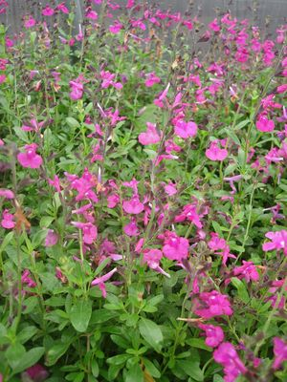
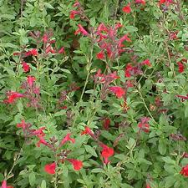
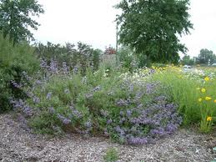
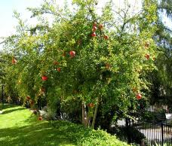
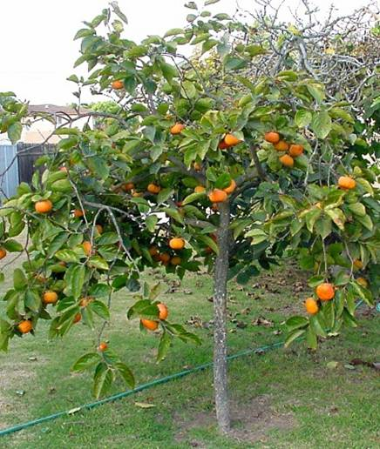
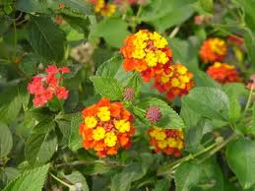
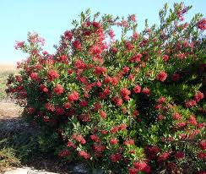
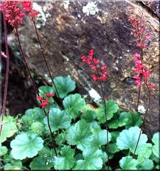
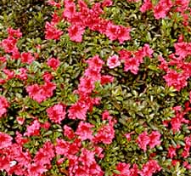
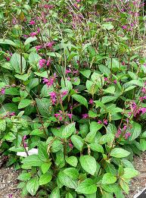
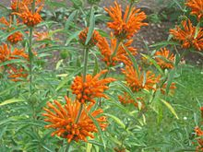
Pomegranate ‘Wonderful’
Persimmon Fuyu
Lantana Trailing Orange
Heteromeles Arbutifolia
Heuchera Sanguinea
Leonotis Leonurus
Pomegranate ‘Wonderful’/ Persimmon Fuyu/ Lantana Trailing Orange
Heteromeles Arbutifolia/ Heuchera Sanguinea/ Leonotis Leonurus
Salvia ‘Allen Chickering’/ Salvia Chiapensis/ Salvia Greggii Red/Pink
Goosberry Pixwell/ Azalea ‘Red Wing’/ Lonicera ‘Hallina’

