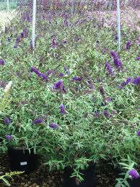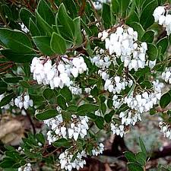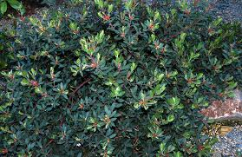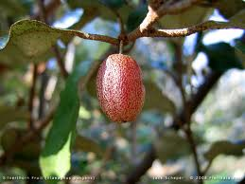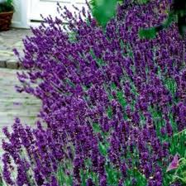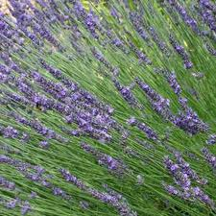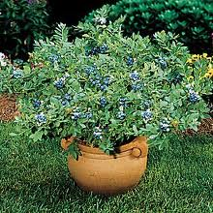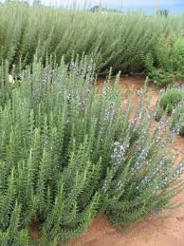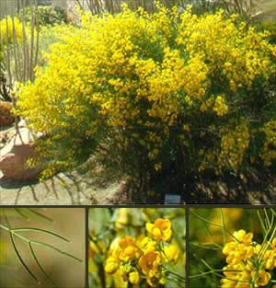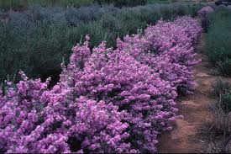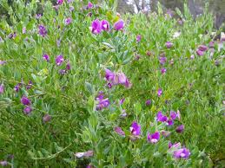
Buddleia, Arctostaphylos McMin
Arctostaphylos ‘Pacific Mist’

Elaeagnus Pungens
Lavandula Angust. ‘Hidcote’
Lavandula Intermedia ‘Provence’
Blueberry ‘Sunshine’
Rosemarinus ‘Tuscan Blue’
Cassia Nemophylla
Leucophyllum Lang. ‘Braveheart’
Polygala Dalmaisiana

